Japan Tsunami Death Toll Rising
By Stephen M. Silverman
Friday March 11, 2011 02:20 PM EST
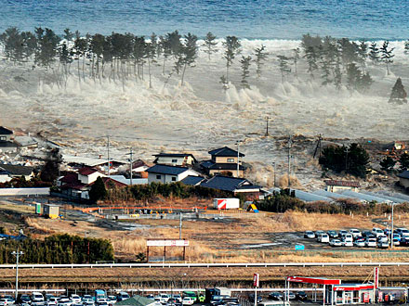
Tsunami in Natori, Miyagi Prefecture
Kyodo/Reuters/Landov
The eyes of the world focused on Japan on Friday, after a horrific 8.9-magnitude earthquake, whose epicenter was close to Tokyo, struck off the country's coast. Experts are labeling the geological disaster the strongest ever in recorded history to rock Japan and one of the largest quakes on earth in the past 100 years. The official death toll, so far, is more than 1,000 people, Japanese media outlets are reporting.

As a result of the earthquake, a tsunami overtook cities and farmland in northern Japan and signaled coastal alerts in Hawaii and up and down the Pacific coasts of North and South America. Waves as high as eight feet began crashing into the northern California coast in Crescent City shortly after 7:30 a.m. Friday, creating surges that pried some boats loose from docks as coastal residents throughout the state rushed to higher ground.

Those living in Santa Cruz Country were advised to evacuate, reports the Los Angeles Times. Newport Beach, on Southern California's gold coast, has closed its waterfront school and cleared the beach and boardwalk, the paper also reports.
RELATED: Taylor Lautner & Kristen Stewart Evacuated in Tsunami Warning

Japan is seeking – and receiving – help from foreign countries in the rescue effort, with President Barack Obama offering condolences to the people of Japan and assuring them that the United States stands ready to help. Soon after news of the disaster reached America, the president called Japanese Prime Minister Naoto Kan, while Secretary of State Hillary Clinton later confirmed that the U.S. Air Force transported vital coolant to a Japanese nuclear-power plant affected by the quake about 170 miles northeast of Tokyo.

The quake and the flood hit in unison at 2:46 p.m. Tokyo time, creating scenes that resembled something out of a science-fiction movie. Transportation and communications systems in the metropolis – a city of 10 million – came to a crashing halt, creating in many a sense of havoc and hopelessness.
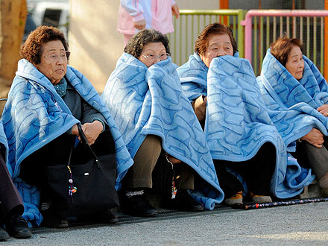
Women on the street in Tokyo after the earthquake
Kyodo / Reuters / Landov

"I never experienced such a strong earthquake in my life," Toshiaki Takahashi, 49, an official in the Sendai City office, in the center of Tokyo's most severely damaged area, told The New York Times. "I thought it would stop, but it just kept shaking and shaking and getting stronger."

On Friday morning, the U.S. State Department was urging friends and family members of those potentially in the path of a West Coast tsunami to contact them as soon as possible.

In terms of offering relief, among several organizations, the International Federation of Red Cross and Red Crescent Societies makes donating quick and easy by accepting contributions via text message. Text "redcross" to 90999 and make a $10 donation. It will appear on your next cell-phone bill.

http://www.people.com/people/article/0,,20473180,00.html?xid=rss-fullcontentcnn

